A project report on

SMARTINTERNZ

FULLSTACK DEVELOPER WITH MERN

MUSIC STREAMING APP

SUBMITED BY:

Team ID : LTVIP2024TMID05420

Team lead : Kakollu Divyadeepika

Team member : Nerella Srivyshnavidevi

Tellakula Sivanagajyothi

Arumalla Krishnaprsanna

Gottipati Meghana

# Introduction:-

Music Player Application is a modern and intuitive platform designed to elevate your music listening experience. Our app offers a seamless way to enjoy your favorite tunes, whether you're on the go or relaxing at home. With a userfriendly interface, personalized playlists, and a vast library of songs, our Music Player App is your ultimate companion for all things music. Explore new tracks, create custom playlists, and immerse yourself in the world of music with our app. Download now and discover a new way to enjoy music!

Technical Architecture:

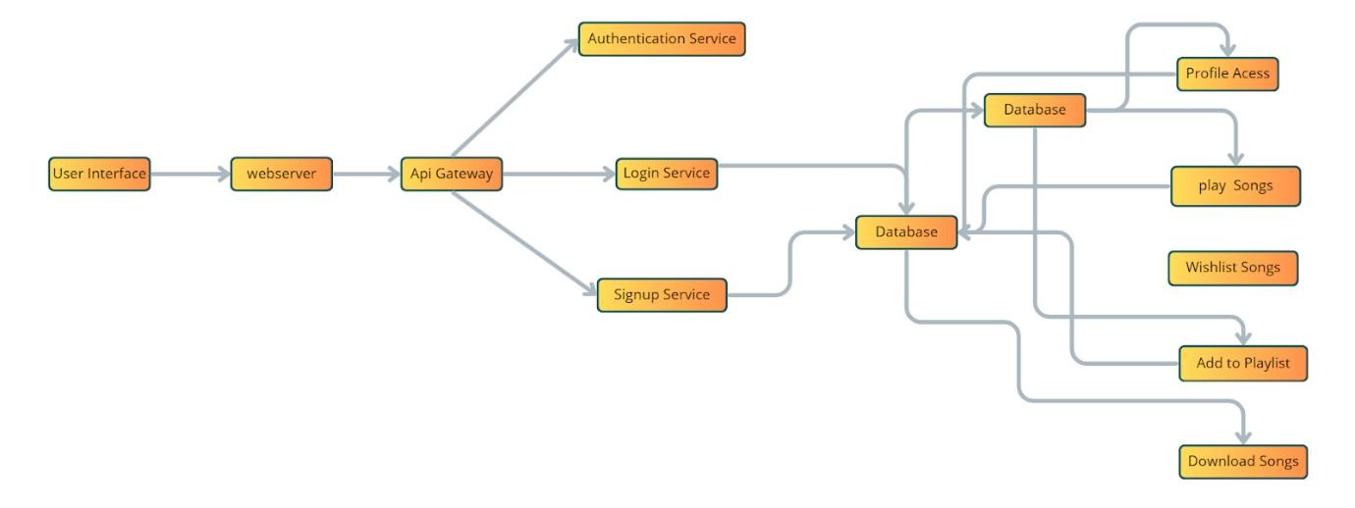

Description:

Welcome to the future of musical indulgence – an unparalleled audio experience awaits you with our cutting-edge Music Streaming Application, meticulously crafted using the powerful MERN (MongoDB, Express.js, React, Node.js) Stack. Seamlessly blending innovation with user-centric design, our application is set to redefine how you interact with and immerse yourself in the world of music.

Designed for the modern music enthusiast, our MERN-based Music Streaming Application offers a harmonious fusion of robust functionality and an intuitive user interface. From discovering the latest chart-toppers to rediscovering timeless classics, our platform ensures an all-encompassing musical journey tailored to your unique taste.

Powered by MongoDB, our application ensures a scalable and efficient database, facilitating lightning-fast access to an extensive library of tracks. Express.js, with its minimalist web application framework, lays the foundation for a responsive and streamlined server, while Node.js ensures high-performance, non-blocking I/O operations, providing a fluid and seamless user experience.

The heart of our Music Streaming Application lies in React, a dynamic and feature-rich JavaScript library. Immerse yourself in a visually stunning and interactive interface, where every click, scroll, and playlist creation feels like a musical revelation. Whether you're on a desktop, tablet, or smartphone, our responsive design ensures a consistent and enjoyable experience across all devices.

Say goodbye to the limitations of traditional music listening and welcome a world of possibilities with our MERN Stack Music Streaming Application. Join us on this journey as we transform the way you connect with and savor the universal language of music. Get ready to elevate your auditory experience – it's time to press play on a new era of music streaming.

ER diagram:

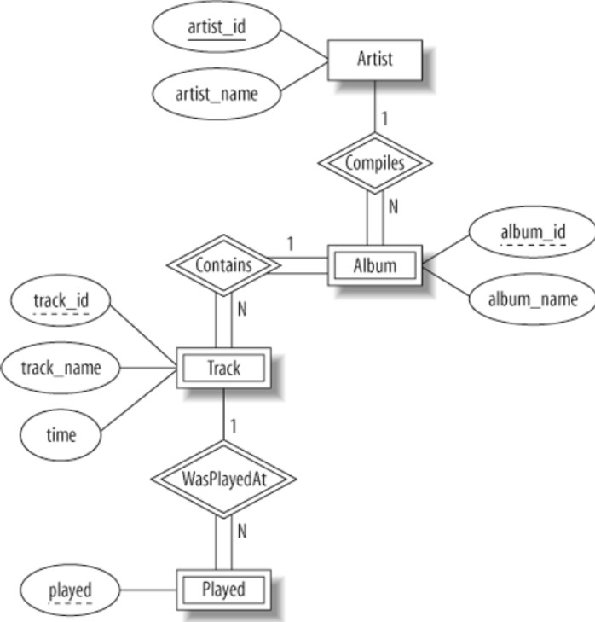

Scenario Based Case Study:

Allen is a passionate music enthusiast who loves discovering new artists and genres. He uses a popular music streaming app to listen to music throughout the day, whether he's working, exercising, or relaxing at home. However, recently, Allen has noticed that he's not as excited about using the app as he used to be. He feels like he's listening to the same songs and artists repeatedly, and the app's recommendations don't seem as personalized or engaging as they once were. Allen is considering trying out a different music streaming service unless the app can offer him a more personalized and exciting music experience.

* User Registration and Authentication: Enable users to create accounts, log in securely, and authenticate their identity to access the music streaming app.
* Song Listings: Display a comprehensive list of available songs with details such as title, artist, genre, and release date.
* Playlist Creation: Empower users to create personalized playlists, adding and organizing songs based on their preferences.
* Playback Control: Implement seamless playback control features, allowing users to play, pause, skip, and adjust volume during music playback.
* Offline Listening: Allow users to download songs for offline listening, enhancing the app's accessibility and convenience.
* Library Management: Provide users with the ability to manage their music library, including adding, removing, and organizing saved songs and playlists.
* Search Functionality: Implement a robust search feature for users to easily find specific songs, artists, or albums within the app.
* User Profile: Allow users to customize their profiles, including profile pictures, bio, and other personalization options.

System overview:

For a system overview documentation of a music streaming app, you'll want to cover various aspects like architecture, user flow, functionalities, and technologies used. Here's a basic outline you can follow:

# *Introduction:*

* Brief overview of the music streaming app.
* Purpose of the document.

# *System Architecture:*

* High-level architecture diagram.
* Components and their interactions (front end, back end, database, etc.).
* Scalability and resilience considerations.

# *User Roles and Permissions:*

* Types of users (listeners, artists, admins, etc.).
* Access levels and permissions for each role.

# *User Flow:*

* Registration and authentication process.
* Searching for music.
* Creating and managing playlists.
* Listening to music (streaming, offline mode).
* Interacting with social features (following artists, liking songs, sharing playlists, etc.).

# *Functionalities:*

* Music catalog management (uploading, metadata management).
* Payment processing (subscription, ad-supported, premium features).
* Recommendations and personalized content.
* Social features (following, sharing, commenting).
* Offline mode and downloads.

# *Technologies Used:*

* Front end (frameworks, libraries).
* Back end (programming languages, frameworks, databases).
* Cloud services (hosting, storage, CDN).
* Third-party APIs (payment gateways, music metadata providers, social media integration).

# *Security Considerations:*

* Data encryption (user data, payment information).
* Authentication and authorization mechanisms.
* Preventing common security threats (SQL injection, XSS attacks, etc.).

# *Performance and Scalability:*

* Load balancing.
* Caching strategies.
* Database optimization.
* Monitoring and analytics.

# *Testing:*

* Types of testing (unit, integration, performance, security).
* Tools and frameworks used for testing.

# *Deployment:*

* Continuous integration/continuous deployment (CI/CD) pipelines.
* Deployment environment (cloud, on-premise).
* Rollback strategies.

# *Maintenance and Support:*

* Bug tracking and issue resolution.
* Software updates and versioning.
* User support channels (helpdesk, FAQs, community forums).

# *Future Enhancements:*

* Potential features for future releases.
* Technologies to explore.
* Feedback mechanisms for users.

# *Conclusion:*

* Summary of the system overview.
* Importance of the music streaming app and its impact.

Installation and setup:

1. Install required tools and software:
   * Node.js.
   * MongoDB.
   * Create-react-app.

1. Create project folders and files:
   * Client folders.
   * Server folders.
2. Install Packages:

Frontend npm Packages

* + Axios.
  + React-Router –dom.
  + Bootstrap.
  + React-Bootstrap.
  + React-icons.

Backend npm Packages

* + Express.
  + Mongoose.
  + Cors.

Referance Link:-

[https://drive.google.com/file/d/1Acv3Lx3PtJcOYkUjREWAzIoCi6w96Tl/view?usp=drive_link](https://drive.google.com/file/d/1Acv3Lx3PtJcOYkUjREWAzIoC-i6w96Tl/view?usp=drive_link)

Backend development :

* + Setup express server
    - 1. Create index.js file in the server (backend folder).
      2. Create a .env file and define port number to access it globally.
      3. Configure the server by adding cors, body-parser.
    - **User Authentication:**
    - Create routes and middleware for user registration, login, and logout.
    - Set up authentication middleware to protect routes that require user authentication.

* + - **Define API Routes:**
    - Create separate route files for different API functionalities such as users orders, and authentication.
    - Define the necessary routes for listing products, handling user registration and login,managing orders, etc.
    - Implement route handlers using Express.js to handle requests and interact with the database.

* + - **Implement Data Models:**
    - Define Mongoose schemas for the different data entities like products, users, and orders.
    - Create corresponding Mongoose models to interact with the MongoDB database.
    - Implement CRUD operations (Create, Read, Update, Delete) for each model to perform database operations.

* + - **User Authentication:**
    - Create routes and middleware for user registration, login, and logout.
    - Set up authentication middleware to protect routes that require user authentication.

* + - **Error Handling:**
    - Implement error handling middleware to catch and handle any errors that occur during the API requests.
    - Return appropriate error responses with relevant error messages and HTTP status codes.

Referance Link:-

[https://drive.google.com/file/d/1ff8bKL5XFYRQhggqn_Jn6QEcjjS8CCGc/view?usp](https://drive.google.com/file/d/1ff8bKL5XFYRQhggqn_Jn6QEcjjS8CCGc/view?usp=sharing)

[=sharing](https://drive.google.com/file/d/1ff8bKL5XFYRQhggqn_Jn6QEcjjS8CCGc/view?usp=sharing)

Database :

1. Configure MongoDB:
   * Install Mongoose.
   * Create database connection.
   * Create Schemas & Models.

1. Connect database to backend:

Now, make sure the database is connected before performing any of the actions through the backend. The connection code looks similar to the one provided below.

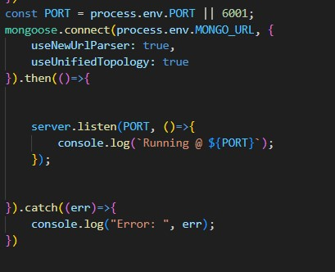

1. **Configure Schema:**

Firstly, configure the Schemas for MongoDB database, to store the data in such pattern. Use the data from the ER diagrams to create the schemas. The Schemas for this application look alike to the one provided below.

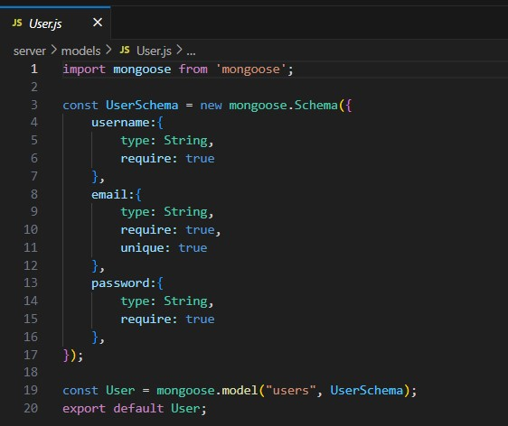

Frontend Development:

1. Setup React Application:

* Create React application.
* Configure Routing.
* Install required libraries.

2. Design UI components:

* Create Components.
* Implement layout and styling.
* Add navigation.

3. Implement frontend logic:

• Integration with API endpoints.

• Implement data binding.

Referance:-

<https://drive.google.com/file/d/1Bqxdk51ZTeHF2z1qyFw5m1bWHot89LdS/view?usp=drive_link>

Project Implementation:

Finally, after finishing coding the projects we run the whole project to test it’s working process and look for bugs. Now, let’s have a final look at the working of our Cab Booking application.

Landing page:-



Login Page:-

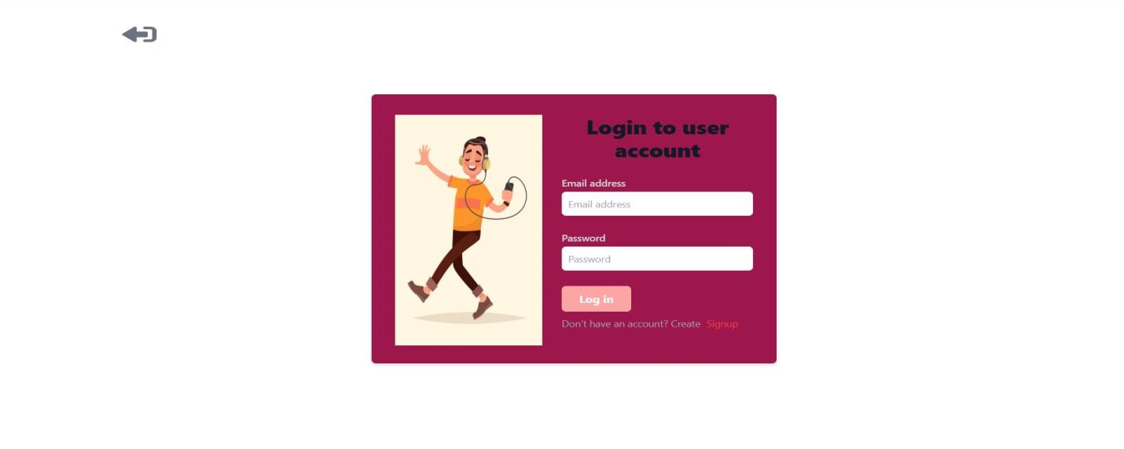

Signup Page:-

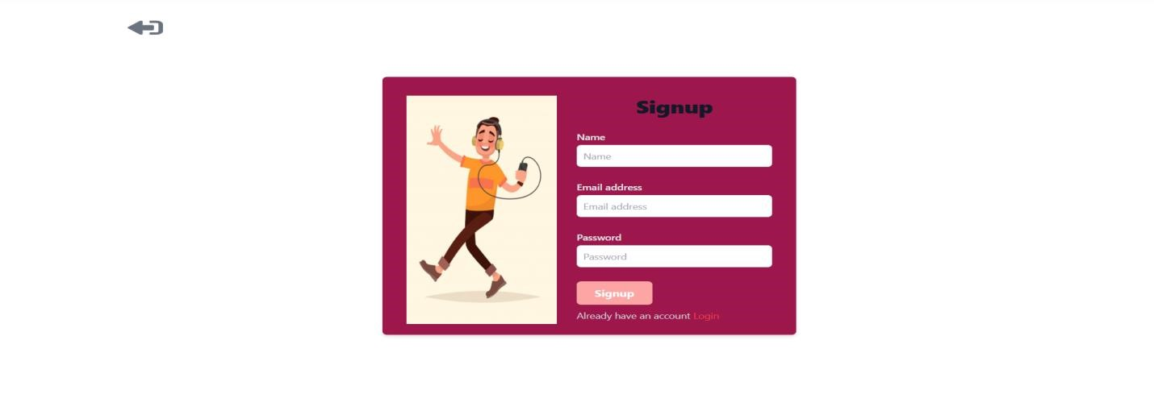

Songs Page:-

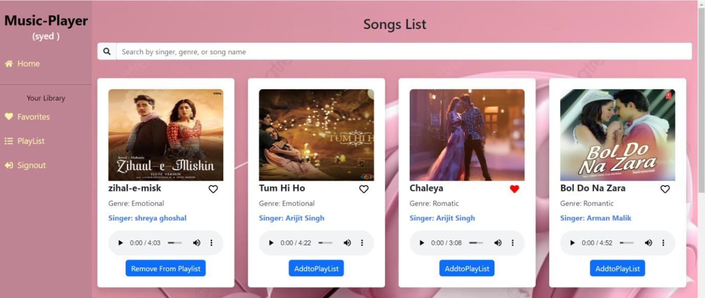

Favorites Page :-

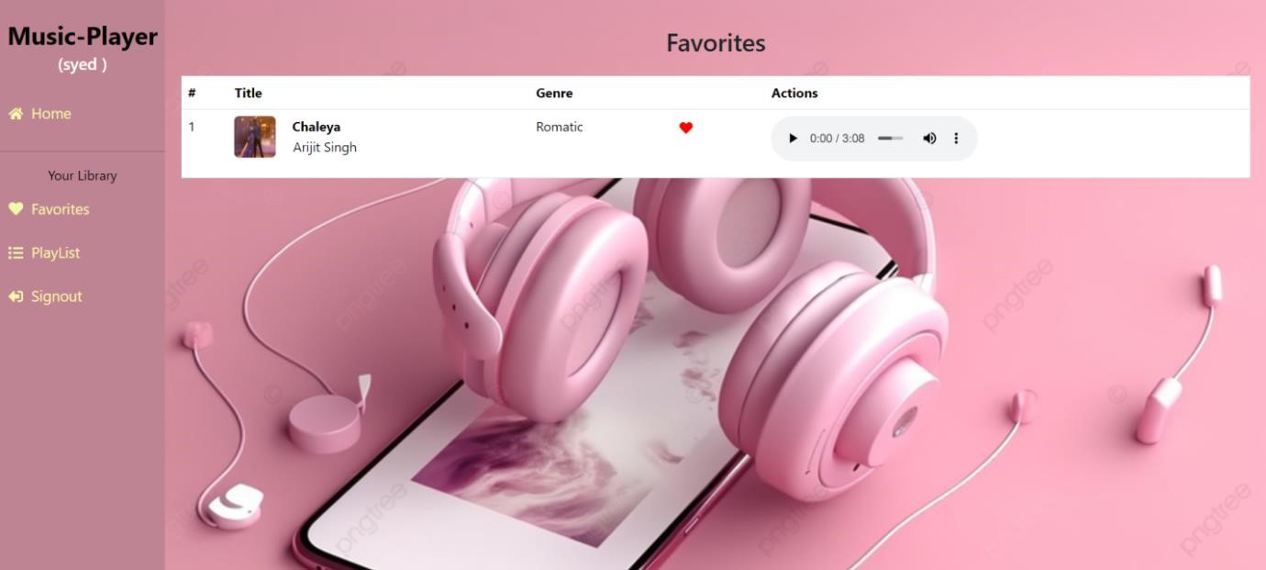

Playlist Page:-

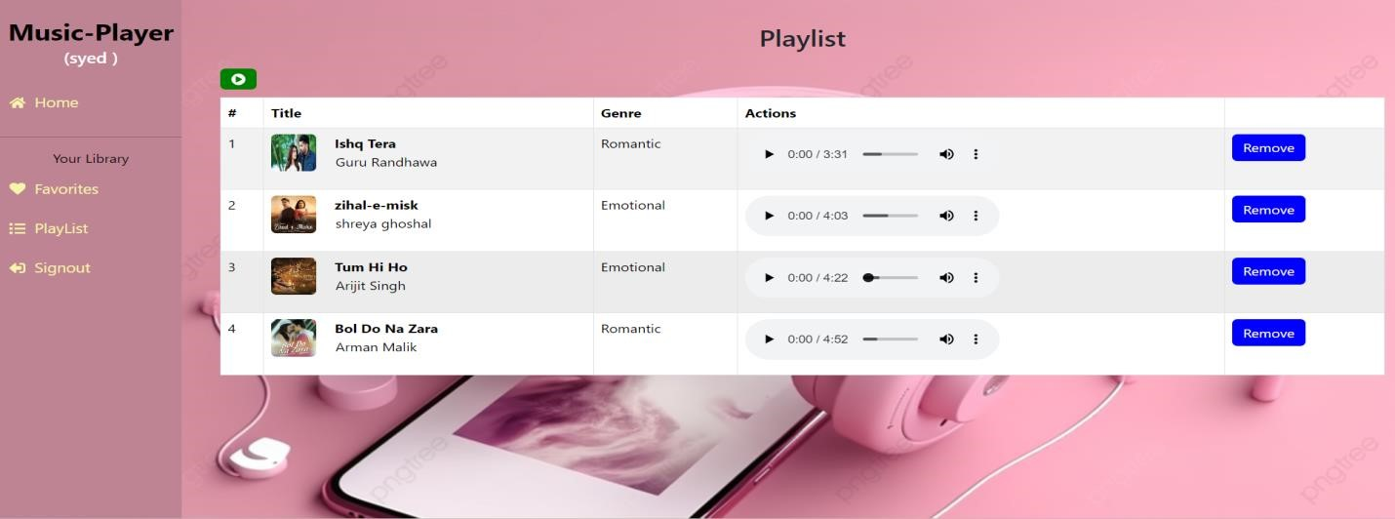

Users Page:-

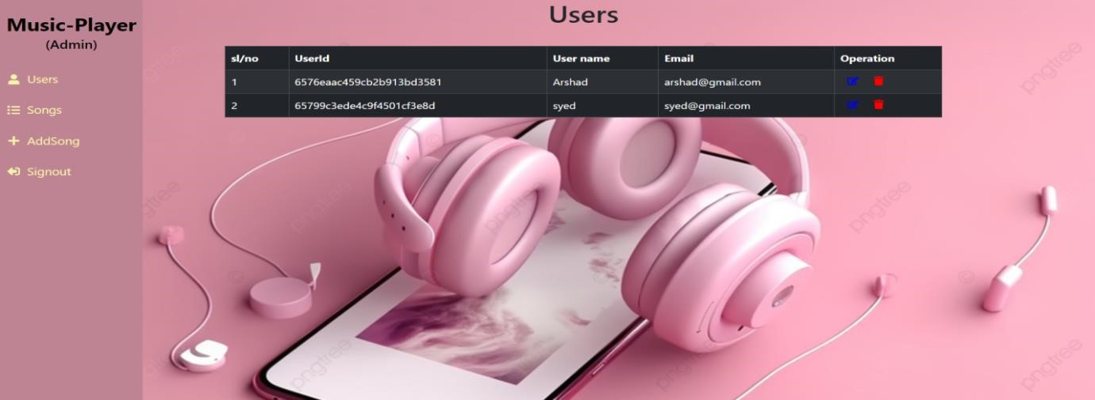

Admin songs List:-

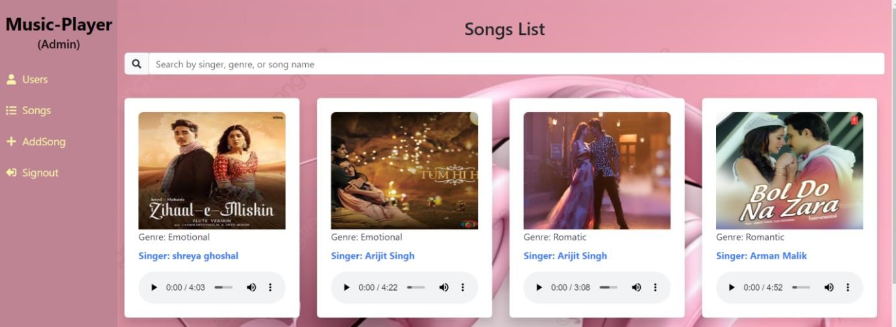

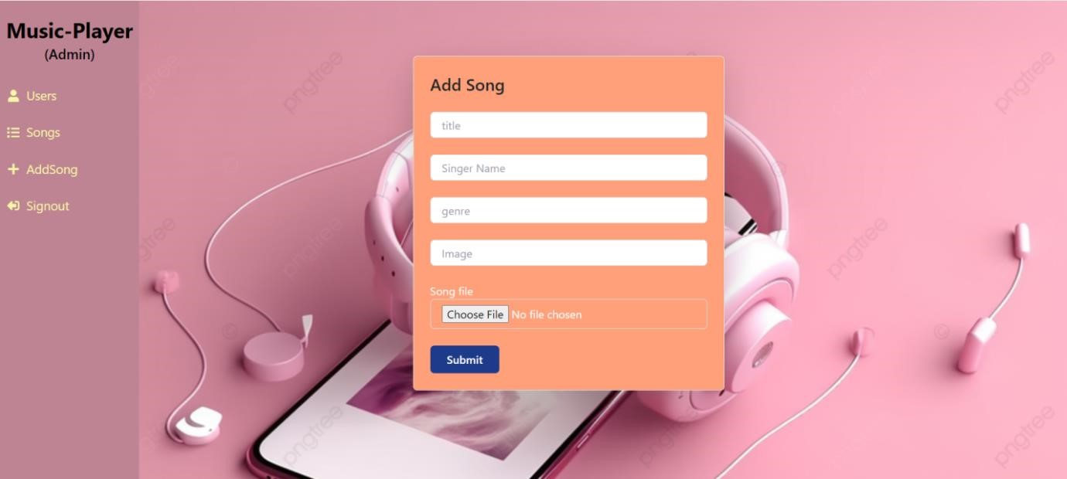

The demo of the app is available at:-

<https://drive.google.com/file/d/1WwxlyubB>[C0mnVmHlevEPJKkTB6ymjH3/view?usp=drive_link](https://drive.google.com/file/d/1WwxlyubB-C0mnVmHlevEPJKkTB6ymjH3/view?usp=drive_link)

Conclusion:

A conclusion for a music streaming app could highlight its impact on the music industry, the convenience it offers to users, the variety of music available, and its potential for future growth and innovation. It could also mention the importance of user experience, personalized recommendations, and the role of technology in shaping the future of music consumption. Overall, the conclusion should emphasize the significance of music streaming apps in shaping how people discover, enjoy, and share music in the digital age.

\*\***THANK YOU\*\***